Base url:   
  
https://elifesciences.org/

Current Issue  
  
  
  
**PDF Available**

Month, Date & Year

English title

Download the pdf

DOI

* **And also save the HTML land page version for each PDFs.   
  PDF not Available  
  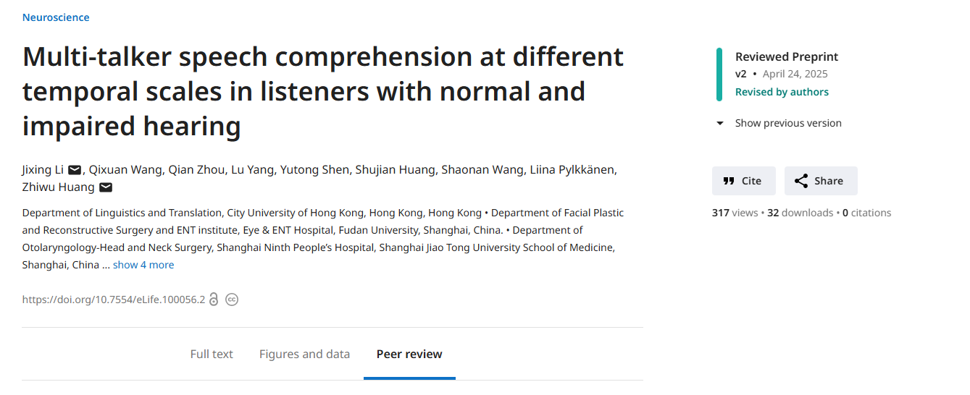**

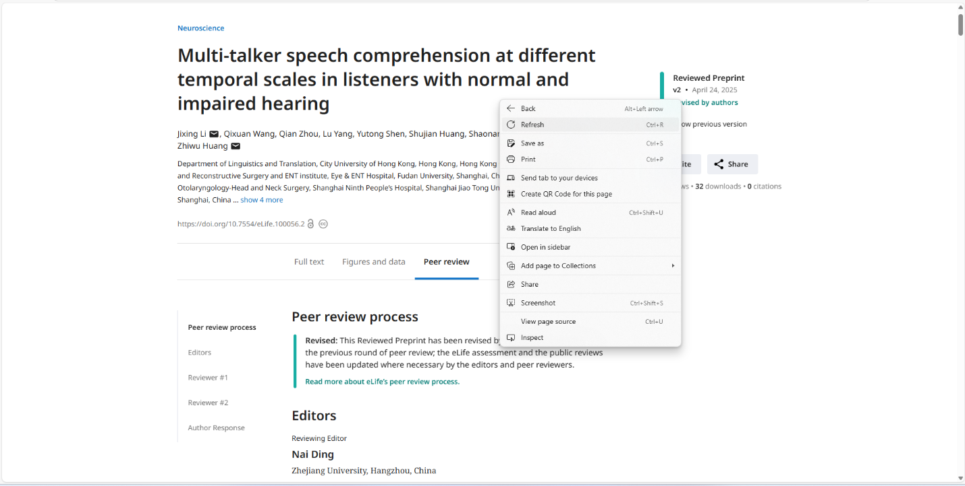

Save as

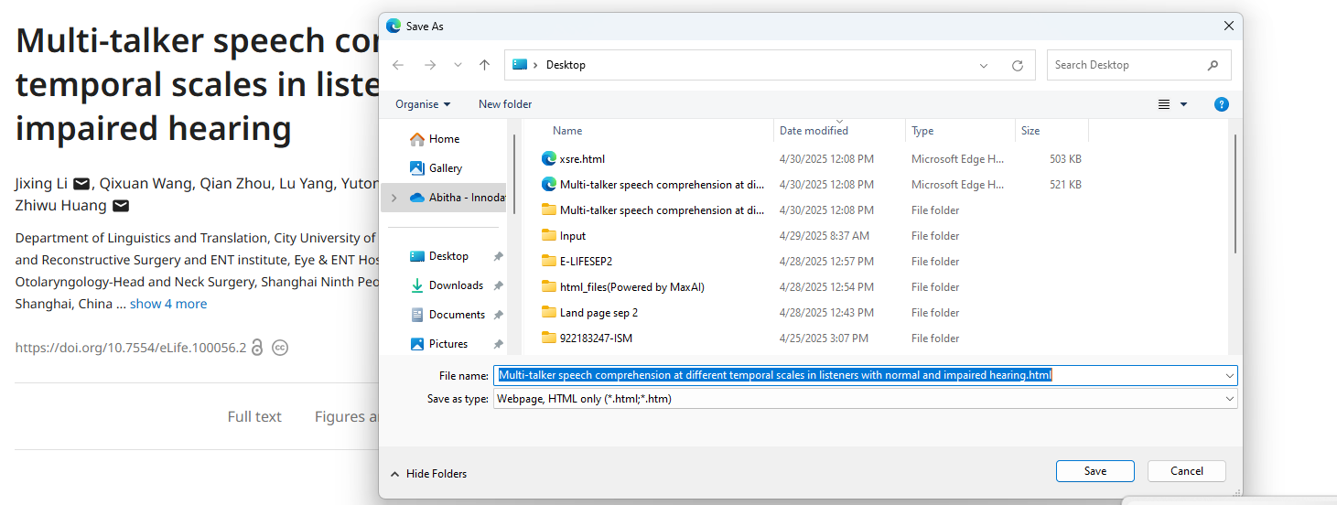

* **Need to download HTML version of land page.**
* **Have to convert html to pdf.**

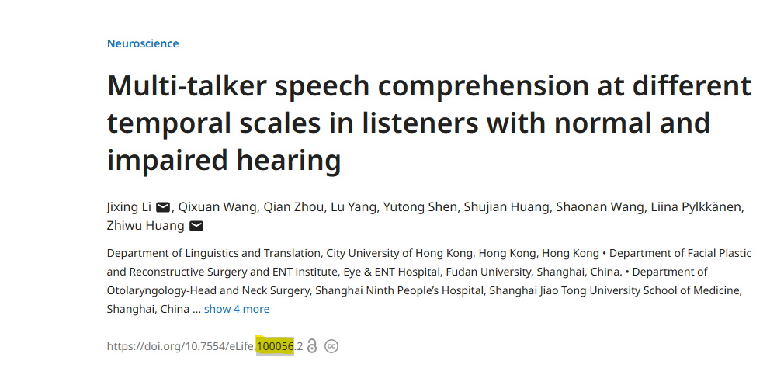

* **Rename the source file , html file as particular doi number as mentioned the above**
* **Example ;** 10.7554/eLife.**100056**.2

**Source file name would be 100056.pdf  
 HTML file name would be 100056.html**